If you are looking for the Cost of Living Comparison Tool, you will find that in the Relocation and Referrals Box at the top of access home page.
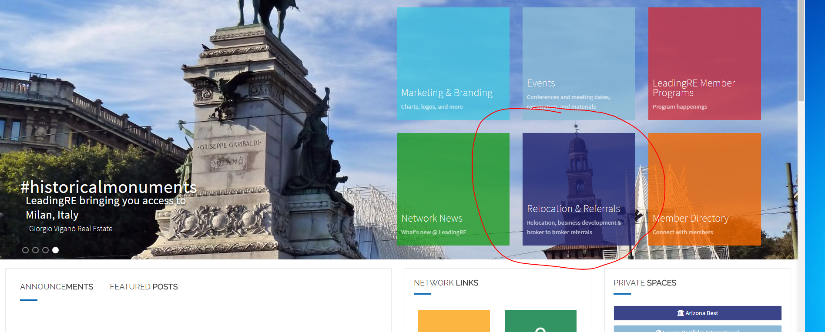

Once in the Relocation and Referrals area, you will see the Cost of Living Tool on the right under “External Links”.
