Access FAQs
How do I update my profile?
Go to the profile area in the upper right hand corner of the home screen. Click on your name. Click on profile on the drop down.
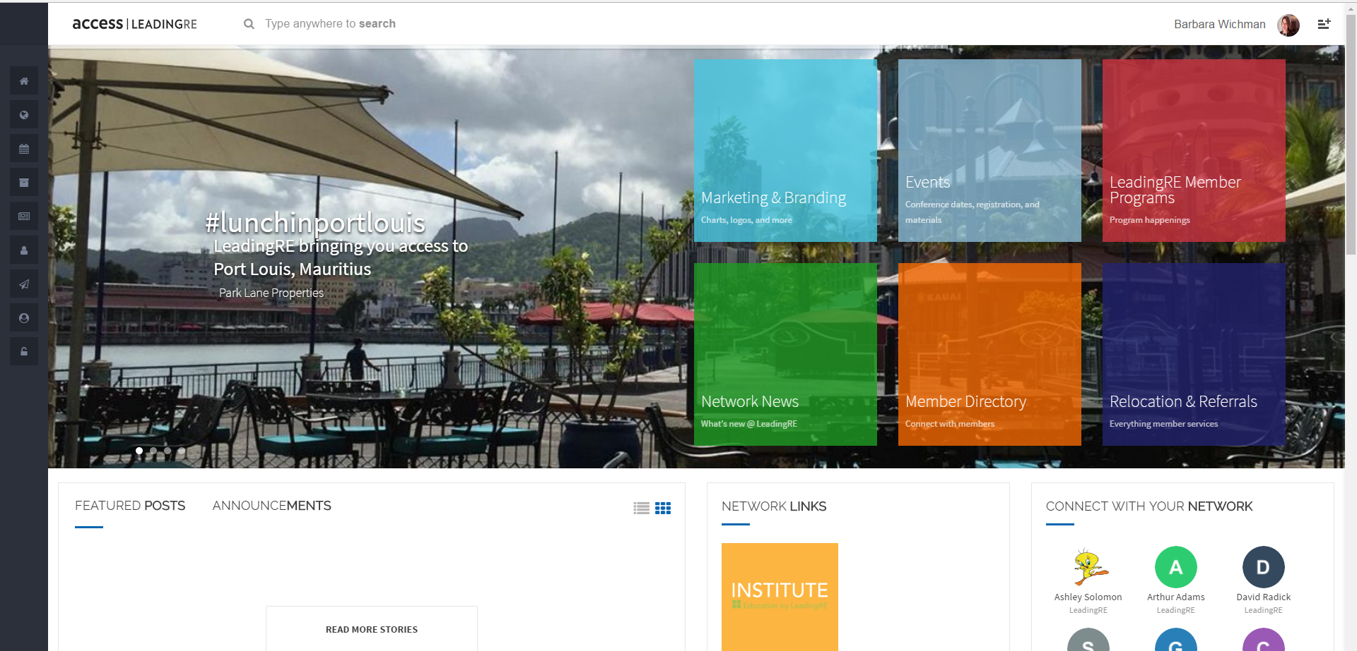
You will be taken to your profile page. Click on the edit icon next to your name to allow editing of your information.
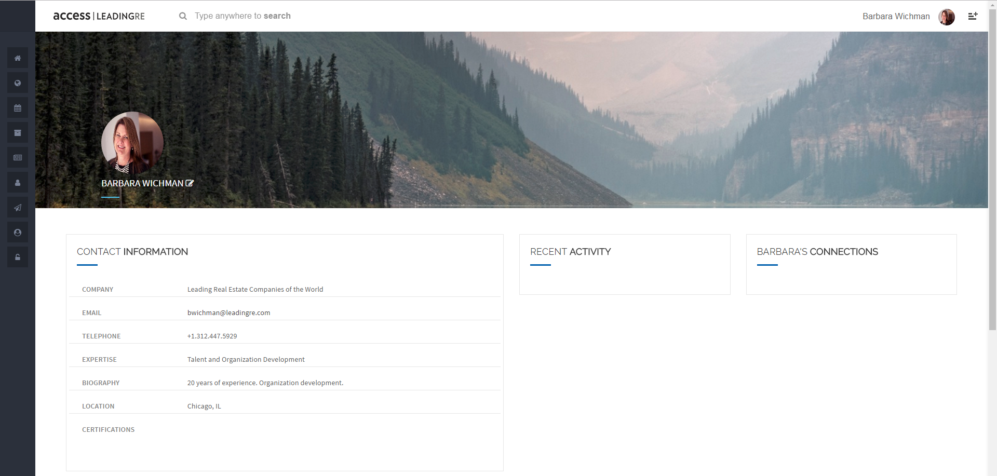

Once you click on the edit button, you will be able to edit your information, upload a photo and change your background. Scroll down to see more options for editing.
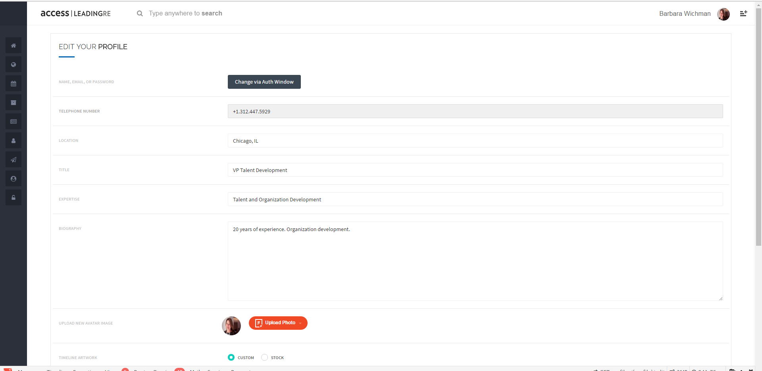

When you ae done, click save.
